**PLANNING MATTERS**

**RISK ASSESSMENT AND MANAGEMENT**

**TEMPLATE 1**



## TEMPLATE 1

**RISK ASSESSMENT AND MANAGEMENT**

**Compiled by:**

**Date:**

**Date to be reviewed by:**

**Documentation:**

1. Risk assessment and management form
2. Table for ranking risks -Adapted for the organisation
3. Checklist for hazard and threats
4. Action Plan: Risk Mitigation and Management
5. Checklist for Building Works

**RISK ASSESSMENT AND MANAGEMENT**

|  |  |  |  |  |  |  |  |
| --- | --- | --- | --- | --- | --- | --- | --- |
| Ref | Risk Description | Likelihood (L) Impact (I) Inherent Risk (Ix L) | Mitigating actions/ controls in place | Residual  **Risk**  (Ix L) | Further action/ Comment Update | Action Date | Person responsible |
| 1 |  |  |  |  |  |  |  |
| 2 |  |  |  |  |  |  |  |
| 3 |  |  |  |  |  |  |  |
| 4 |  |  |  |  |  |  |  |
| 5 |  |  |  |  |  |  |  |
| 6 |  |  |  |  |  |  |  |
| 7 |  |  |  |  |  |  |  |
| 8 |  |  |  |  |  |  |  |
| 9 |  |  |  |  |  |  |  |
| 10 |  |  |  |  |  |  |  |
| 11 |  |  |  |  |  |  |  |
| 12 |  |  |  |  |  |  |  |
| 13 |  |  |  |  |  |  |  |
| 14 |  |  |  |  |  |  |  |
| 15 |  |  |  |  |  |  |  |
| 16 |  |  |  |  |  |  |  |
| 17 |  |  |  |  |  |  |  |
| 18 |  |  |  |  |  |  |  |
| 19 |  |  |  |  |  |  |  |
| 20 |  |  |  |  |  |  |  |
| 21 |  |  |  |  |  |  |  |
| 22 |  |  |  |  |  |  |  |
| 23 |  |  |  |  |  |  |  |
| 24 |  |  |  |  |  |  |  |

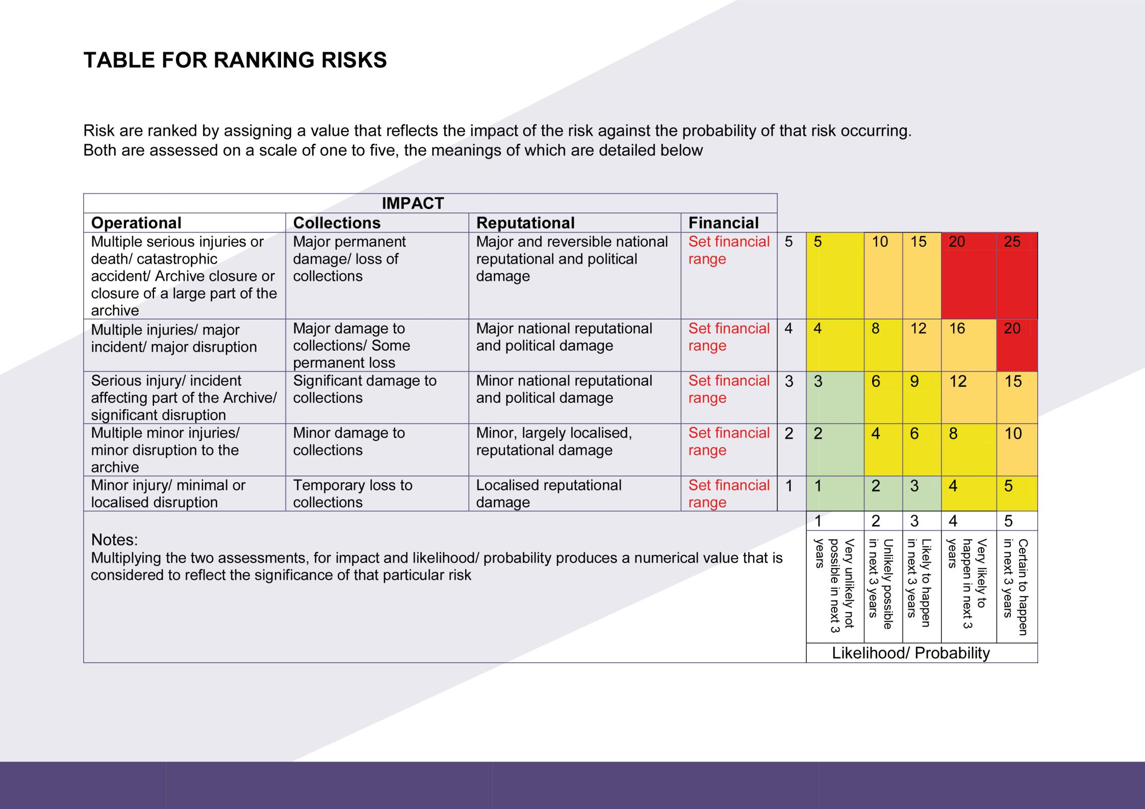

# CHECKLIST FOR HAZARDS AND THREATS

*External Internal*

|  |  |
| --- | --- |
|  | Fire |
|  | Wildfire |
|  | Lightning strike |
|  | Flooding - surface run off |
|  | Flooding - rivers |
|  | Flooding - coastal |
|  | Flooding - rising water table |
|  | Earth tremor/ earthquake |
|  | Landslide - affecting building structure, site |
|  | Landslide - impacting infrastructure, access |
|  | Storm damage - affecting building structure, site |
|  | Storm damage - impacting infrastructure, access |
|  | Civil unrest |
|  | Vandalism |
|  | Terrorism |
|  | Power failure |
|  | Nearby hazards:   * Airport * Railway line * Nuclear power plant * Neighbouring/ adjoining buildings * Chemical plant * Military base |
|  | Construction/ building works nearby |
|  | Snow |
|  | Other(s) |

|  |  |
| --- | --- |
|  | Poor building maintenance |
|  | Building/ refurbishment works |
|  | Fire |
|  | Hazardous collections   * Asbestos * Pesticides/ Insecticides * Chemicals * Radioactive materials * Unstable materials - e.g., cellulose nitrate |
|  | Asbestos |
|  | Water ingress - roof leaks; thawing snow |
|  | Water - leaking service pipes |
|  | Water - sources of water above collections |
|  | Chemical stores/ cabinets |
|  | Vandalism e.g, acid attack |
|  | Terrorism |
|  | Civil protest |
|  |  |
|  |  |
|  |  |
|  |  |
|  |  |
|  |  |
|  |  |
|  |  |
|  |  |

# ACTION PLAN: RISK MITIGATION AND MANAGEMENT

|  |  |  |  |  |  |
| --- | --- | --- | --- | --- | --- |
|  | Action to be carried out | Priority H/M/L | Person responsible | By when? | Date completed |
| 1 |  |  |  |  |  |
| 2 |  |  |  |  |  |
| 3 |  |  |  |  |  |
| 4 |  |  |  |  |  |
| 5 |  |  |  |  |  |
| 6 |  |  |  |  |  |
| 7 |  |  |  |  |  |
| 8 |  |  |  |  |  |
| 9 |  |  |  |  |  |
| 10 |  |  |  |  |  |
| 11 |  |  |  |  |  |
| 12 |  |  |  |  |  |
| 13 |  |  |  |  |  |
| 14 |  |  |  |  |  |
| 15 |  |  |  |  |  |
| 16 |  |  |  |  |  |
| 17 |  |  |  |  |  |
| 18 |  |  |  |  |  |
| 19 |  |  |  |  |  |
| 20 |  |  |  |  |  |

**CHECKLIST FOR BUILDING WORKS**

### The Checklist below is a guide to aspects you may need to consider.

The Checklist should be adapted and amended, according to the nature of the work being undertaken, the type of collection and the  
 possible impact of the work on the collection.

|  |  |  |
| --- | --- | --- |
| **CHECKLIST FOR BUILDING WORKS** | | |
| **Activity** | **Actions** | **Completed** |
| Obtain detailed information about the proposed works |  |  |
| Identify risks to the collection arising from the proposed works |  |  |
| Identify measures needed to mitigate risks to the collection |  |  |
| Identify areas to be protected, collections to be relocated |  |  |
| Identify collections that might need to be moved, and plan accordingly for their move |  |  |
| Identify collections that cannot be moved but which require in-situ protection,  and plan for this |  |  |
| Cost and budget for protection, packing, removal, storage of collections |  |  |
| Update emergency plans with change of location of collections |  |  |
| Speak to your organisation's insurers before the work is commissioned |  |  |
| Provide an introduction for contractors, covering the significance of the building and  collection to raise awareness of the exceptional nature of the work environment |  |  |
| If hot works are essential, ensure that an effective hot works procedure is in place |  |  |
| Ensure that a temporary fire detection and alarm system is in place and active  throughout the works |  |  |
| Monitor effectiveness of protection measures and condition of the collection |  |  |
| Limit spread of dust and debris through the site by screening areas |  |  |
| Wherever possible materials introduced for protection should be inflammable, or flame retardant |  |  |